Kyle Gilpin

May 11, 2021

IT FDN 110 A

Assignment 05

<https://github.com/Tekpro007/IntroToProg-Python/tree/main>

Creating a To Do List

# Introduction

In this assignment, I will be adding onto an existing template file to finish the script. I will be writing the missing functions for importing data from the user and display the data from a text file stored on the hard drive. I will be using dictionaries to store the data. I will also be posting my work to GitHub.

# Creating the PyCharm Project file

Before starting my script, I created a new project in PyCharm and named it assignment 05. To create the project, I opened PyCharm and selected New Project under the File Menu. I chose the location to be C:\_PythonClass\Assignment05 and unselected the creation of the main.py welcome script as seen in figure 1.

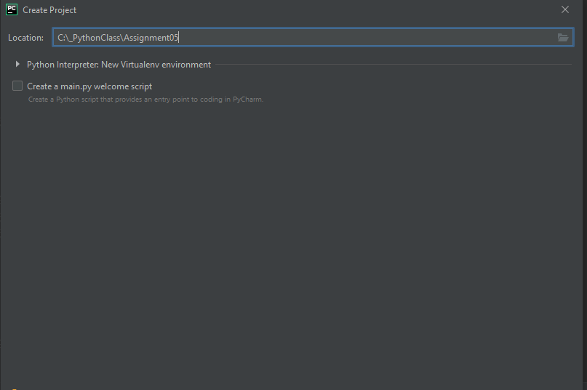

Figure (Creating Project in PyCharm)

I moved the Python script Assigment05_Starter.py from the class module into the assignment05 folder. I then navigated from File->Open in PyCharm to the script Assigment05_Starter.py and clicked ok as see in figure 2.

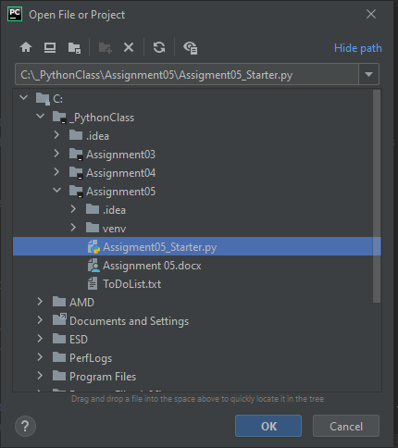

Figure Importing starter Python file

# Finishing the Assigment05_Starter.py

To begin with, I looked over the code that was existing. I noticed under the heading “processing” in step #1 that I wasn’t going to be able to add any code to this without using a function which this assignment said to skip on. So, I proceeded to step 3 of the program since step 2 of showing the menu to the user had already been completed. I built the reading from a file portion of the code by using the existing variable strData and objFile. Both variables had already been declared by the previous developer. I created a for loop to open the rows within the text file, and I used the split function to import the data into a list. From there, I converted the list into a dictionary with my last step to code printing out the files in the dictionary. I changed the formatting, so that the data was displayed in an easier to understand format. This is seen in Figure 3.

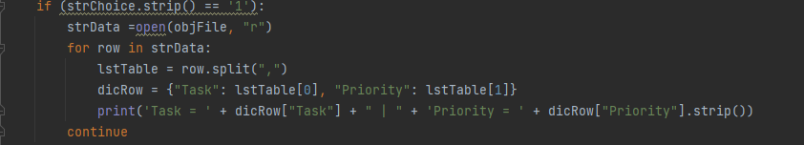

Figure Show existing data to user

I then proceeded to step 4. I once again used the existing variables that had already been declared. I did have to create two new variables for inputting data from the user. I then stored this data into the dictionary. This code is seen in figure 4.

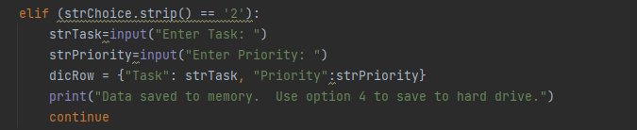

Figure Add data from the user input.

For removing data, I set the dictionary to value to for dicRow to no value which clears the value in memory. This is seen in figure 5.

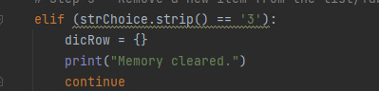

Figure 5 Clearing data from memory

For step 6, I wrote the code to store the data that was captured in step to a text file. This was achieved by opening the text file and storing the data that was in the dicRow dictionary to the file. This is seen in figure 6.

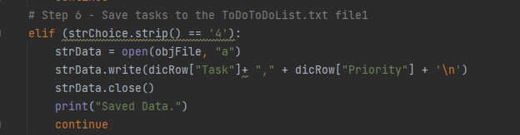

Figure 6 Saving data to the text file.

For the final step in the program, I setup a print statement that stated that the program was exiting. This is seen in figure 6.

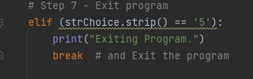

Figure 6 Exiting program.

With my script finished, this is the output of my script running in PyCharm as seen in figure 7.

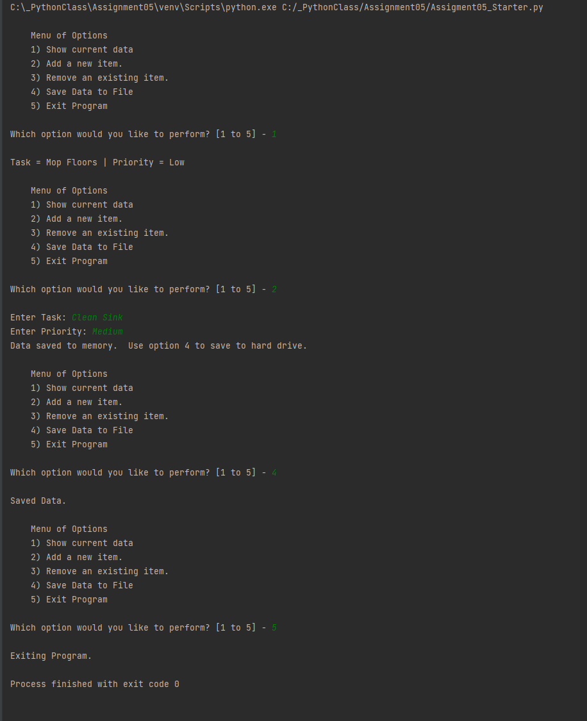

Figure 7 Running in PyCharm

This is a screenshot of the file that it created as seen in figure 8.

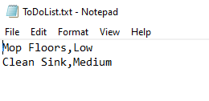

Figure 8 Output of text file

# Summary

As part of this assignment, I learned to work with a template script that had some of the data already created. I found it to be helpful in some areas and more difficult in others. This demonstrates the need to document and code in logical manner to allow for other developers to easily understand the code. I also learned how to load data from a text file and load it into a dictionary. As a final part, I uploaded my files to the GitHub code repository.